Analyzing and Predicting the Effect of Climate Change Factors on Buffalo’s Weather.

Data Intensive Computing

Team:

Balasubramanian Chandrasekar

Shankarram Saravanan

Prof. Erik Mikida

November 14, 2022

Phase 2 - Machine Learning and Statistical Analysis.

- Algorithms/Visualizations

- RandomForest Regressor
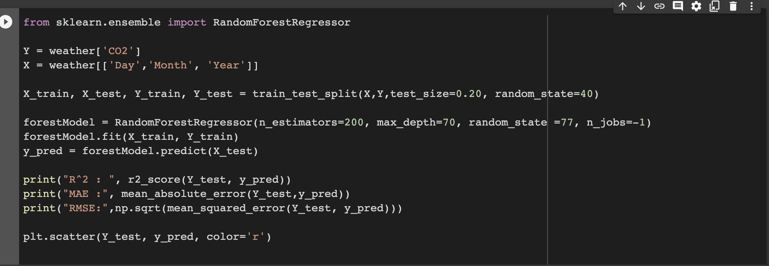
We try to predict the values of CO2 against the date. (Explanation in next section)

2. XGBooster Regressor
We try to predict maximum temperature (TMAX) using the Extreme Gradient Boost Regressor. (Explanation in next section)
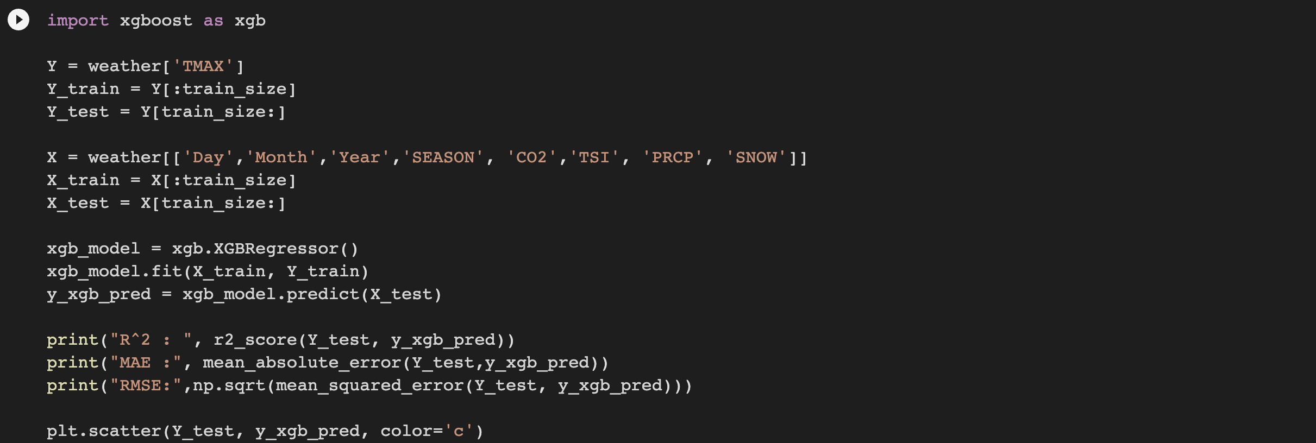

3. Support Vector Regressor.
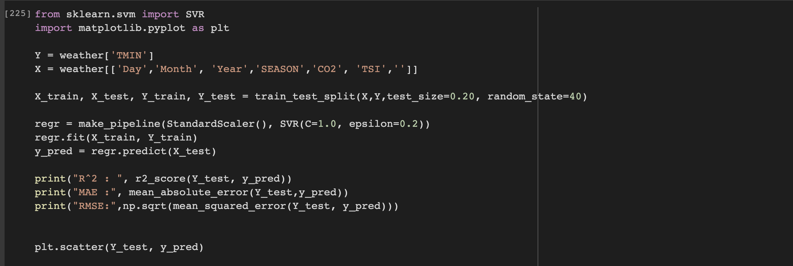
We try to predict the minimum temperatures using the Support Vector Regressor (SVR). (Explanation in next section)

4. SARIMAX model
We try to predict the average temperature of a period using the Seasonal Autoregressive (Explanation in next section)
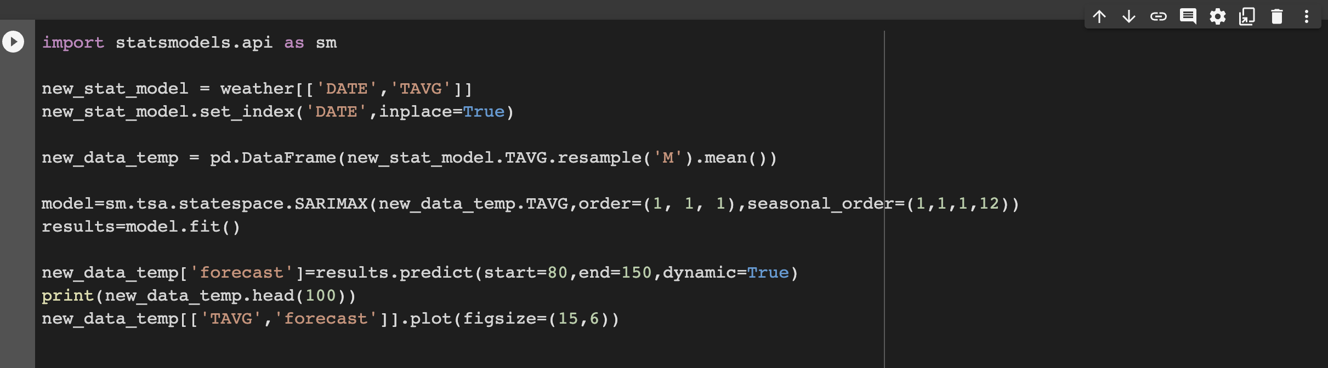

5. Neural Network - Univariate LSTM

We try to learn the pattern of the average temperature in the entire dataset by utilizing univariate LSTM neural network. (Explanation in next section)
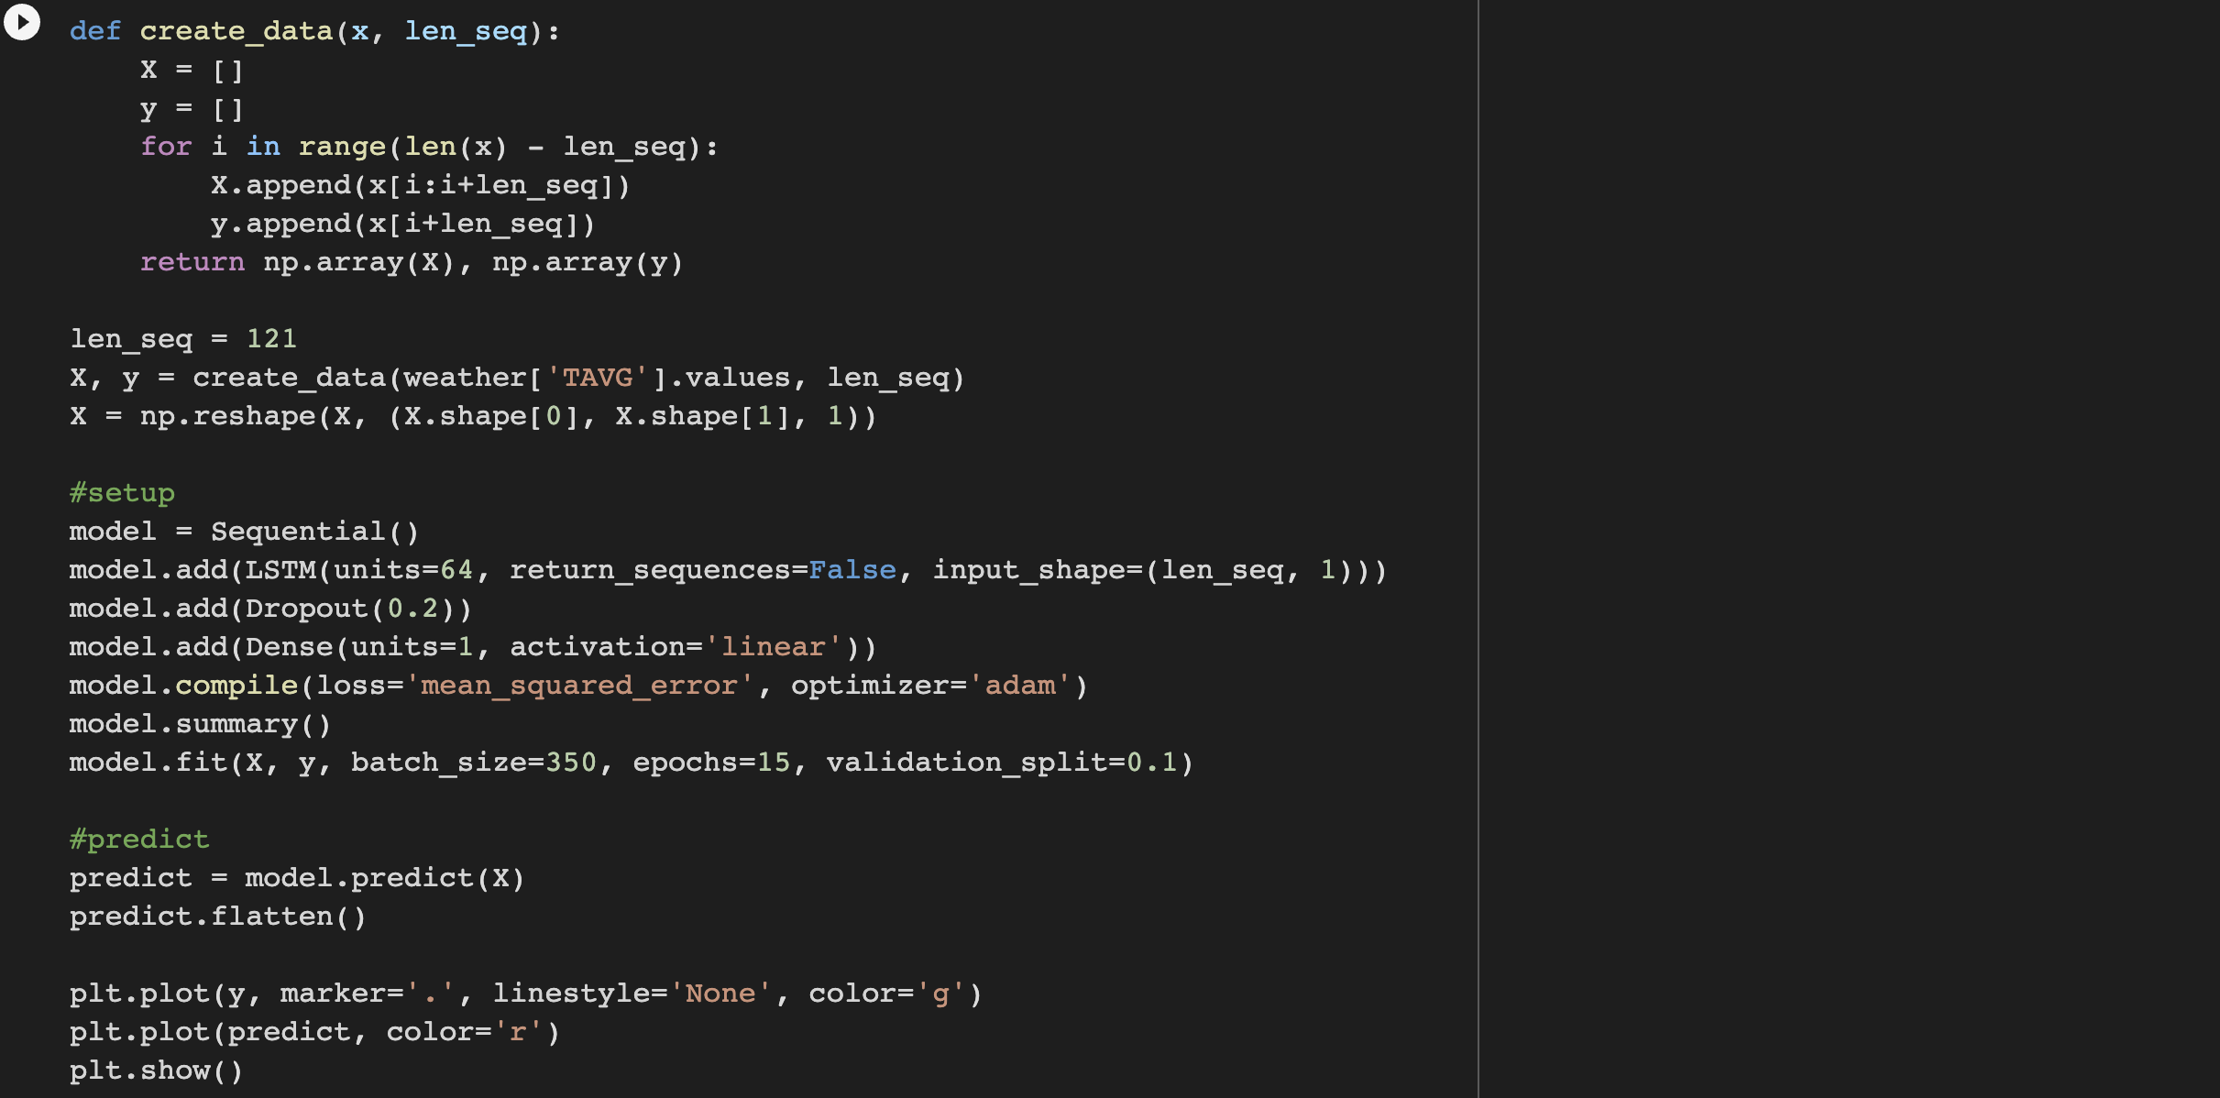

2. Explanation

- Prediction of CO2 using RandomForest Regressor.
Prediction of CO2 values can be done using regression models as the EDA revealed the CO2 to increase over time. Therefore, to predict the CO2 value, the day, month and year are used as independent variables and the CO2 value is considered to be the dependent variable.

We finalized using the RandomForest Regressor for predicting the CO2 values as it performed best out of all the regression models that we tried.

The r^2 value that we got was 0.99 which shows that there was a significant correlation between the dependent and the independent variables.
The mean absolute error (MAE) score was 0.26 which was acceptable for the model.

Scatter plot shows predicted vs true values.
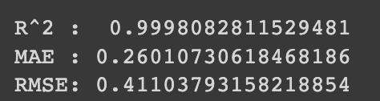

2. Prediction of TMAX using the XGBoost Regressor.

The maximum temperature is another metric that we can predict. Since it is a numerical data and all the other columns in the data frame are also numerical data, we chose to use another regression model for this.

We chose the day, month, year, CO2, precipitation, snow, season as features and used the maximum temperature as the variable to be predicted.

The R^2 score was 0.81 which shows that the correlation between the selected features and the predicted variable is good. We considered any R^2 score above 0.7 to be good.

The MAE for this prediction was 3.74 degrees which we considered as acceptable considering we have decades of data.

Scatter plot shows predicted vs true values.
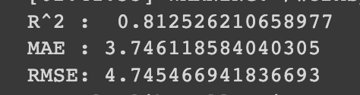

3. Predicting the minimum temperature using the Support Vector Regressor (SVR)

The minimum temperature is yet another major data that we need to predict so that we can calculate the temperature average with it.
We use the Support Vector Regressor in this case as this is another numerical data that we are working with.

We chose the day, month, year, CO2, precipitation, snow, season as features and used the minimum temperature as the variable to be predicted.

The R^2 score was 0.78 which shows that the correlation between the selected features and the predicted variable is good. We considered any R^2 score above 0.7 to be good.

The MAE for this prediction was 3.65 degree.

Scatter plot shows predicted vs true values.
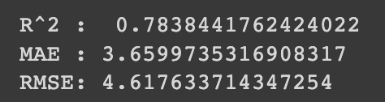

Models for predicting the average temperature

4. Predicting the average temperature using the SARIMAX model.

After predicting the CO2, minimum and maximum temperature, we can predict the average temperature. This time we implement a popular statistical model that is very frequently used on time series data which is the Seasonal Auto Regressive Integrated Moving Average with eXogenous (SARIMAX) model.

This model takes into account the seasonal trends in the data as the weather over the years display a seasonal trend.

For this, we predict the monthly temperature averages for a period of time and the predicted results are very near to the actual values.

To us, SARIMAX would be a top contender for the final modeling that we use since it accounts for the seasonal trends.

5. Predicting the average temperature using univariate LSTM

We pass the whole data to the LSTM model to predict the TAVG. We get a pretty good result with the prediction similar to SARIMAX.

We use an epoch value of 15 beyond which there is no significant reduction in loss.
We use a linear activation function and use the adam optimizer.

References
SARIMA - https://towardsdatascience.com/time-series-forecasting-with-arima-sarima-and-sarimax-ee61099e78f6
LSTM - krishNaik (YouTube)
XGBoost Regressor - https://xgboost.readthedocs.io/en/stable/python/python_api.html
RandomForest Regressor - https://scikit-learn.org/stable/modules/generated/sklearn.ensemble.RandomForestRegressor.html
SupportVector Regressor - https://scikit-learn.org/stable/modules/generated/sklearn.svm.SVR.html

https://towardsdatascience.com/time-series-from-scratch-train-test-splits-and-evaluation-metrics-4fd654de1b37
https://medium.com/analytics-vidhya/applying-linear-regression-on-a-weather-data-set-e84901120f88

